**A Technical Report on the Development Process of a Web Application Porfilio**  
22018575  
School of Computing and Mathematics, Keele University  
CSC-20021 Web Technologies  
Dr Goksel Misirli  
December 19, 2023  
Word Count: 1065

1.0 Introduction: 4

1.1 Tast Report: 4

1.2 The Header and footer the convenience of PHP and modular design 4

2.0 Designs principles and approach for a web developer CV 4

2.1 Contents of the CV Right Side 6

2.2 Contents of the CV Left Side 6

2.3 Advantages and Disadvantages in UI design 6

3.1 Functionality of the code and changing between the first 3 graph types 7

3.2 Functionality of the code and changing between the other 2 graph types 8

3.3 Advantages and disadvantages of weather 9

5.0 The library and its components 11

5.2 Display.php displaying all details of a single record 12

5.3 submit.php The hidden option 12

5.4 Advantages and disadvantages of the library management system 13

6.0 Improvements 13

6.1 How the library management can be extended for re-use 13

1.0 Introduction: 3

1.1 Tast Report: 4

1.2 The Header and footer the convenience of PHP and modular design 4

2.0 Designs principles and approach for a web developer CV 4

2.1 Contents of the CV Right Side 5

2.2 Contents of the CV Left Side 5

2.3 Advantages and Disadvantages in UI design 5

3.1 Functionality of the code and changing between the first three graph types 6

3.2 Functionality of the code and changing between the other two graph types 7

3.3 Advantages and disadvantages of weather 7

5.0 The library and its components 9

5.2 Display.php displaying all details of a single record 9

5.3 ‘Submit.php’ The hidden option 10

5.4 Advantages and disadvantages of the library management system 10

6.0 Improvements 11

6.1 How the library management can be extended for re-use 11

# **1.0 Introduction:**

This technical report will outline the decisions made in the design and implementation process. There are 3 primary objectives; they are, designing and displaying a CV for a web application role, creating a page with the chart.js to visualise the weather forecast for Stoke-on-Trent area and to create a library management system. Books can be added to the system by administrators.

## **1.1 Tast Report:**

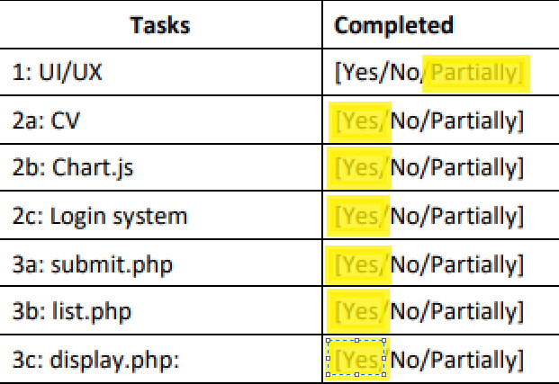

**1.2 The Header and footer the convenience of PHP and modular design**  
A design choice for the header and footer is to store them in their own PHP file and then calling them using the ‘require_once’ function therefore, any changes that take place will happen across all pages without the need to change them on each page.

# **2.0 Designs principles and approach for a web developer CV**

The CV can be split into 3 main elements, the main element which acts as a card allowing for the CV to be centred and 2 other elements called ‘CVLeftSide’ and ‘CVRightSide’. These elements are organised with the display grid type allowing for a responsive design for both pc and mobile user. ‘CVLeftSide’ and ‘CVRightSide’ for Pc users are side by side whilst for mobile users they are stacked for a continuous scrolling ability as demonstrated below in figure 1. Text is displayed with colours to set the cv apart from others, whilst being pleasing to the eye and is easily distinguished from the background colours.

**Figure 1**

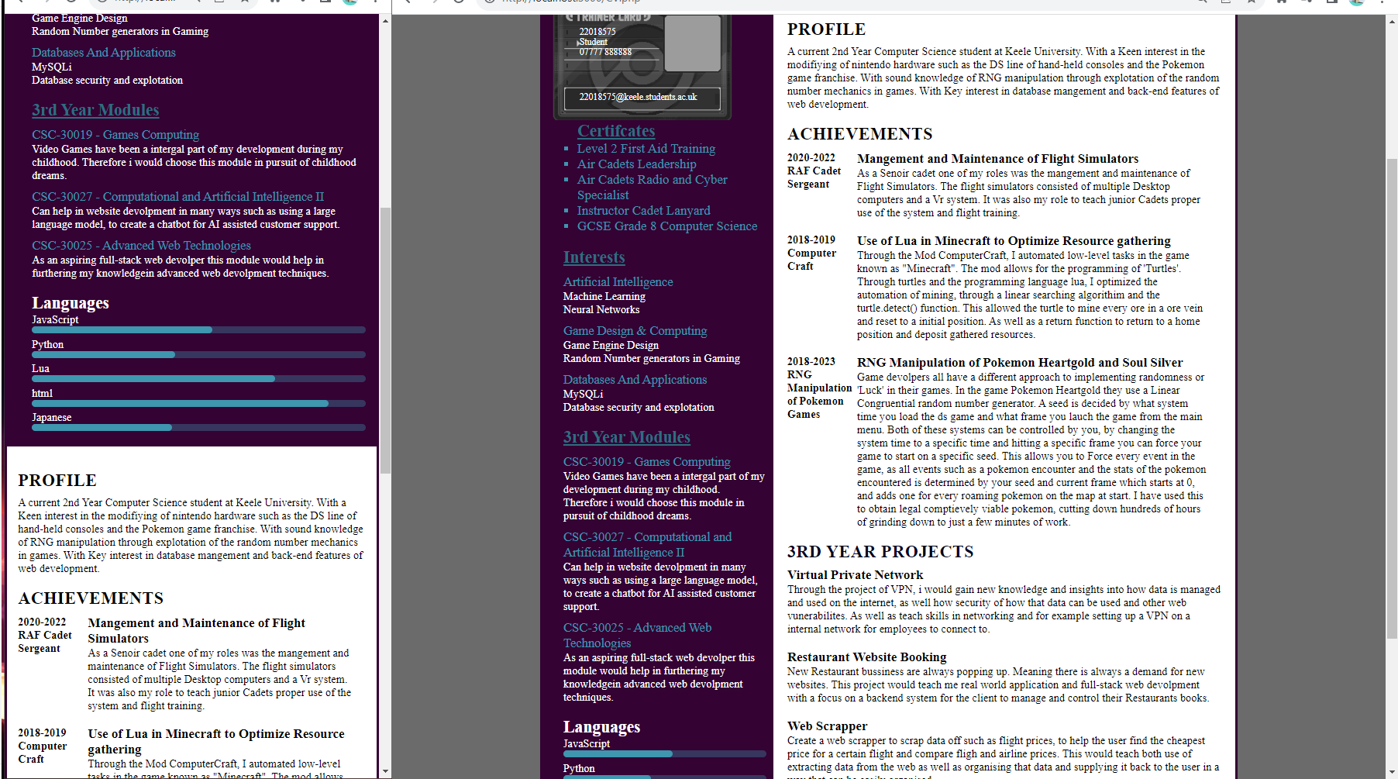

**2.1 Contents of the CV Right Side**

‘CVRightSide’ content is focused to be concise information. First certificates display quantifiable qualifications to the employer, with a focus on leadership and working with a team. This shows the employer I am a team centric individual. Third year modules are referenced to their respective modules as well as containing reasons for why I have an interest in pursuing them.

**2.2 Contents of the CV Left Side**  
‘CVLeftSide’ contains more detailed content with larger bodies of text. It is focused on achievements related to computer science as well as 3rd year projects I would like to pursue. The projects are selected to demonstrate my interest towards the internet and web development. This shows the employer a versatile interest in topics surrounding web development.

## **2.3 Advantages and Disadvantages in UI design**

Advantage – all main content centred on page is reactive to a change in screen size.

Colour choices are consistent.  
Disadvantage – UI was not made responsive for the navigation bar images. Only works on Fullscreen desktop

**3.0 Using chart.js to visualise weather information**

The weather graph provides support for five graph types and the ability to switch between days as well having a responsive design for mobile.

## **3.1 Functionality of the code and changing between the first three graph types**

The weather graph first three graph types are Line, bar and radar. The issue for switching between these three chart types was the centring of data on the x axis as switching would cut off two of the bars from the first point of data. This is solved by resetting the coordinates every time the chart type is changed. The Code and examples of this can be seen in figure 2.

**Figure 2**

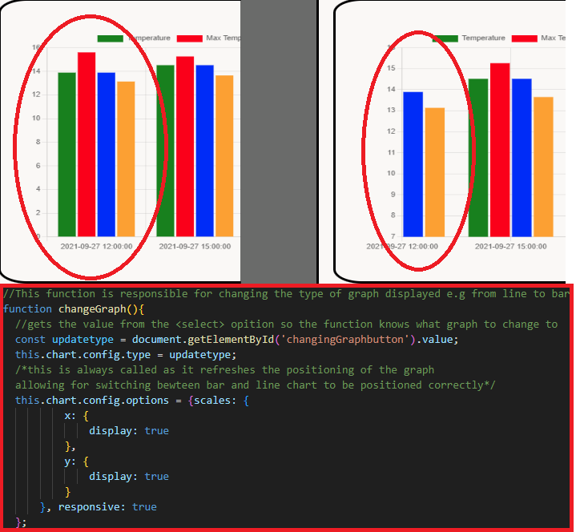

**3.2 Functionality of the code and changing between the other two graph types**  
The other two graph types are pie and doughnut. To provide support for these graphs there is a need to add colour values for the label to properly use the data whilst removing it for other graphs to not break them. This is achieved through an ‘if-else’ statement where if pie or doughnut is selected, colours are updated, else colours are set to default. Whilst not the most optimal type of graphs to look at attempt was made to add support for them. The issue and solution can be seen in figure 3.

**Figure 3**

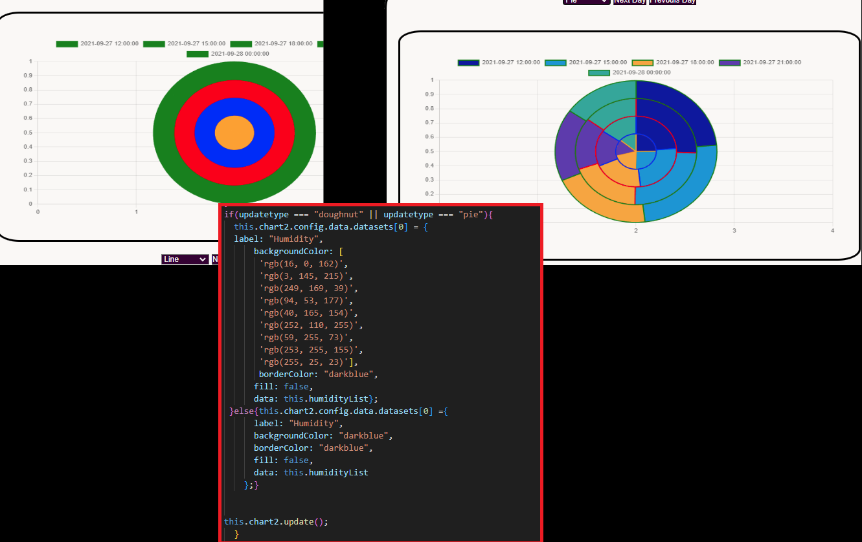

**3.3 Advantages and disadvantages of weather**  
Advatanges – a variety of charts can be chosen and different chart type for humidity and temperature can be compared against each other.  
Disadvantage – to add new or change days their index number must manually be changed in an array in a switch statement, or a new case added for a new day.

**4.0 The login system and its security features**  
The login system is for administrators. It stores username and passwords in a CSV file, in which passwords are hashed. This adds a layer of security to the users' passwords. The login system also displays errors when an empty input or field is filled incorrectly this can all be seen in figure 4.

**Figure 4**

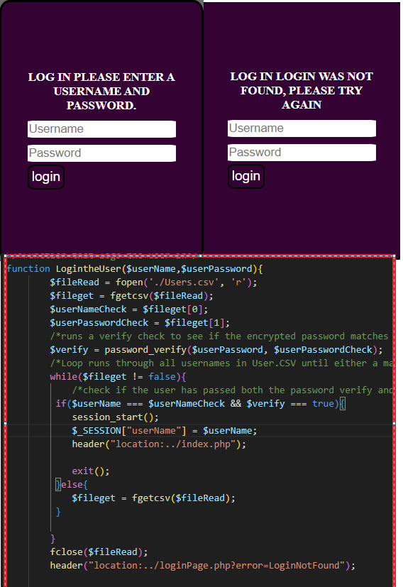  
**4.1 Advantages and disadvantages of the login system**  
Advantages – passwords are hashed.  
Disadvantages - user input is not sanitized through ’htmlentities.’

# **5.0 The library and its components**

The library contains three components ‘list.php’, ‘display.php’ and ‘submit.php’ and use two different methods of creating new dynamic elements.  
**5.1 List.php, Listing the records**

‘List.php’ requires listing out all the records of books in the system. To achieve this, I used a ‘while’ loop in PHP surrounding the html element which continues until a false input is returned, meaning the end of file is reached. Each element displayed consists of a Title, Author and ISBN. Each element is wrapped with an Anchor element which takes you to ‘display.php’ whilst printing the ISBN in the URL. Illustrated in figure 5.  
**Figure 5**

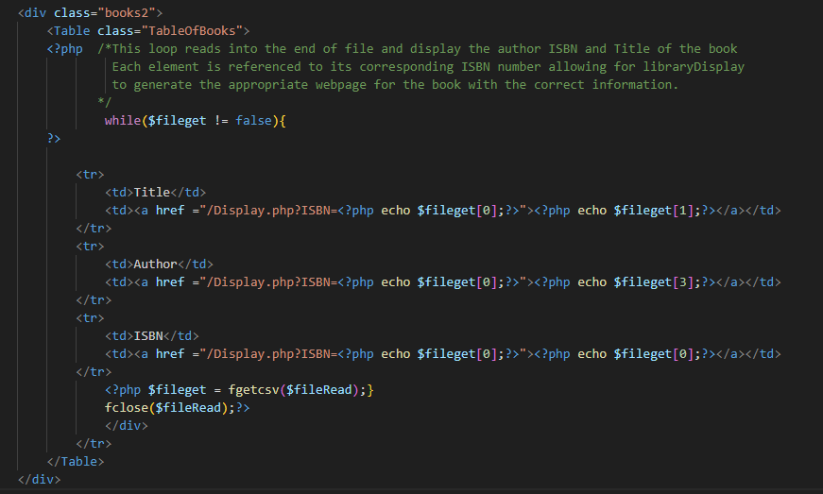

**5.2 Display.php displaying all details of a single record**  
In order to display all details of a single record with only one webpage I use ‘$_GET’!  
When a record is clicked on the Anchor element, which has the ISBN of the record attached to it, this can be gotten with ‘$_GET’. This value is then used to search for the correct record before displaying all its elements. Another feature of the display page is its ability to list out an infinite number of modules that are anchored to their respective pages using the same method as ‘list.php’ but with a ‘for loop’. Illustrated in figure 6.

**Figure 6**

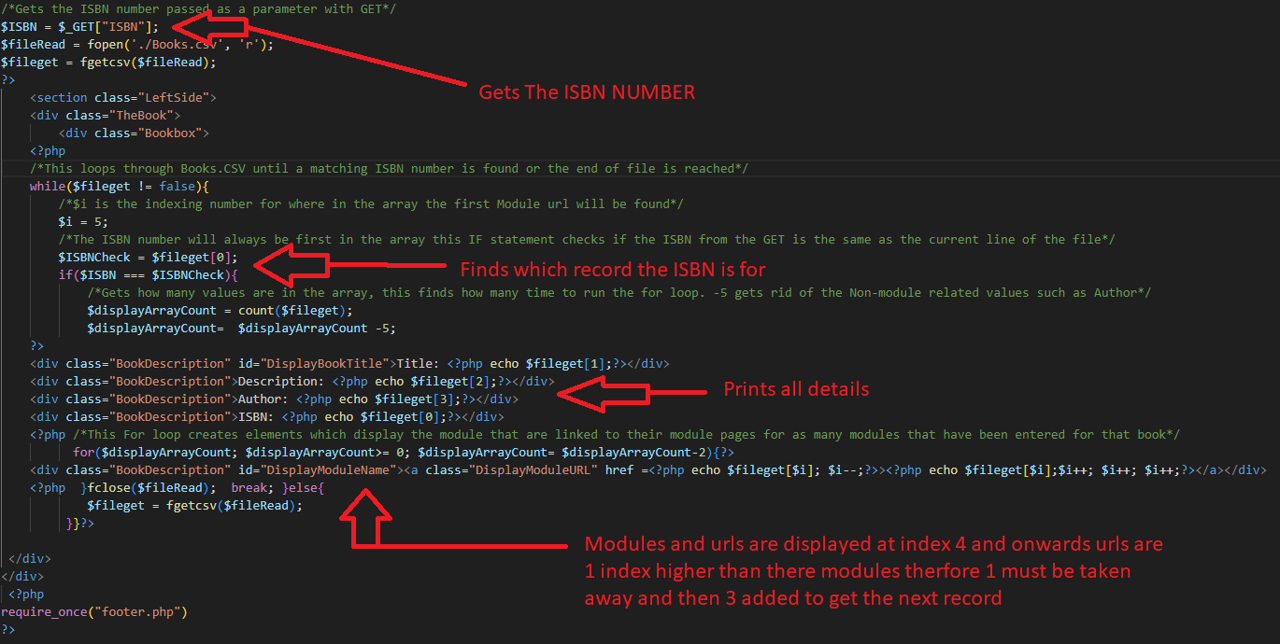

**5.3 ‘Submit.php’ The hidden option**  
This option is only available to those logged in, by checking if $_Session is set. ‘Submit.php’ requires a minimum of six inputs from the user but can take infinite number of inputs for module and URL. By using the ‘create-element’ function in ‘JavaScript’, to create extra input boxes for the user, through the click of the button these created elements have the correct name attached to them so their input is then submitted to PHP. Illustrated in figure below. The ISBN must only contain numbers and not already exist when inputted.

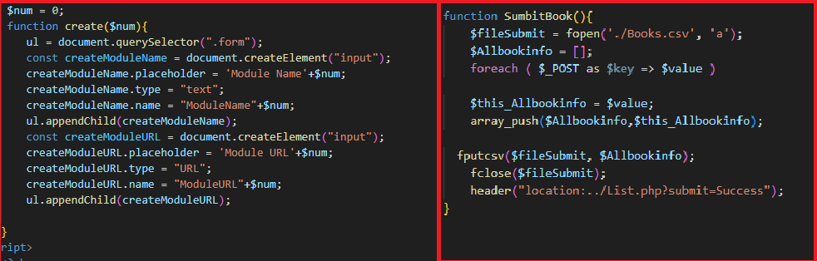

**5.4 Advantages and disadvantages of the library management system**  
Advantages – Provides all the functionality for the brief including allowing multiple modules inputted Disadvantages – If an entry has extra boxes added these boxes are not checked if they contain anything. This can display warning messages in ‘display.php’ to the user and causes bugs. Input is not sanitized.

**6.0 Improvements**   
- UI and UX can be improved from 2010 style website to modern 2024 style  
-Code sanitizing user input.  
-More checks for submit inputs to prevent bugs caused by user error.

**6.1 How the library management can be extended for re-use**  
A library usually deals with thousands if not tens of thousands of books. To improve the re-usability and continued use of this system it is recommend to use a database system such as the one shown below.

**Figure 7**

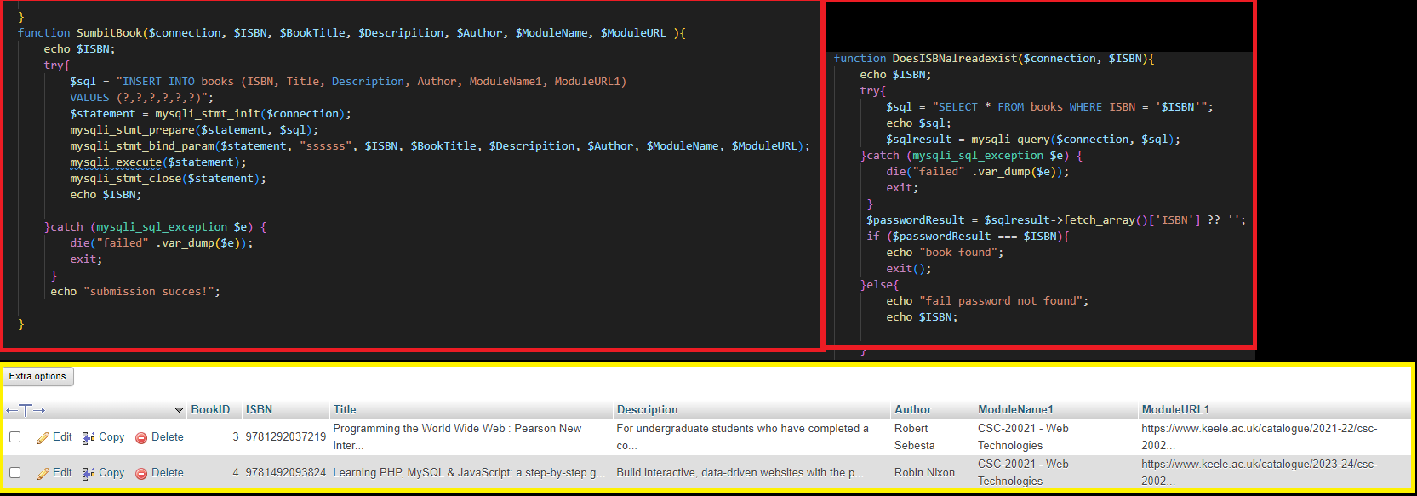

**References**

**Learning PHP, MySQL & JavaScript: a step-by-step guide to creating dynamic websites | 6th ed**

by Robin Nixon 2021 ISBN: 9781492093824